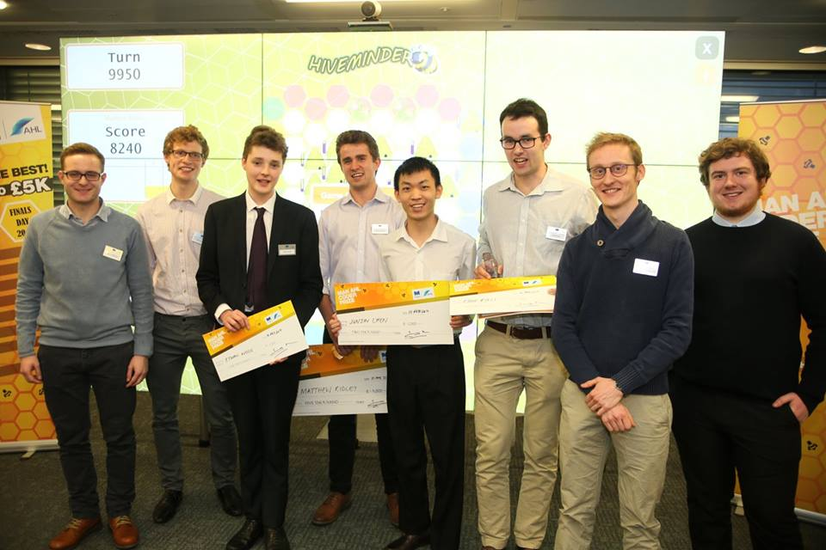

Junjin Chen

Education:

* (2015-2017): The University of Sheffield
  + 1st class
* (2014-2015): Sheffield International College (SIC)
  + Average score: 81
* (2012-2014): Guigang Senior High School in Guangxi, China

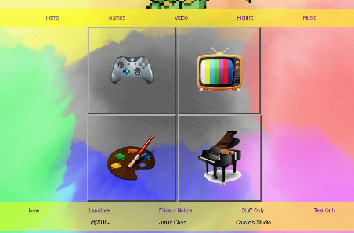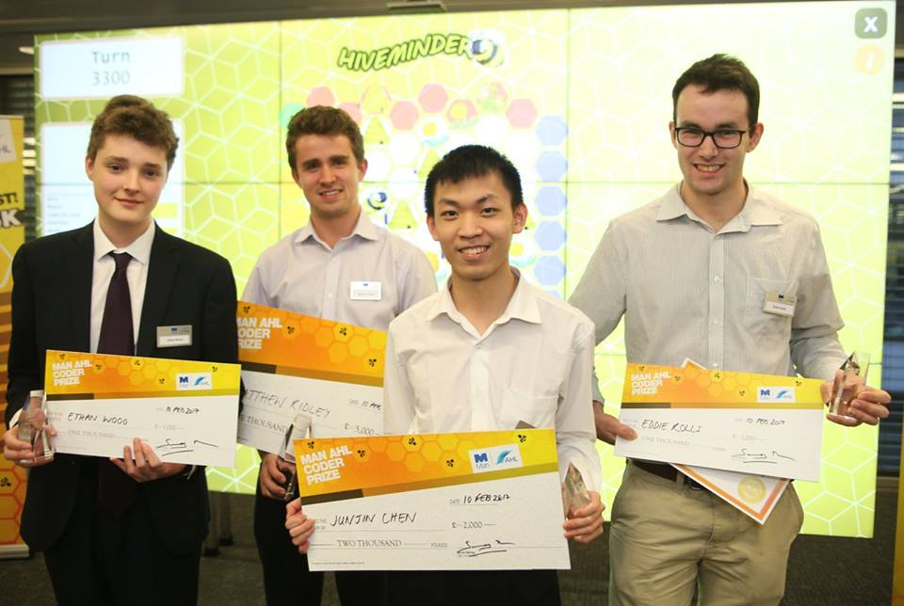

Experience:

* Social Innovation Lab
  + Creativity, Management Skill, Teamwork Ability, Speech Skill.
* Examination condition filming volunteer
  + Performance Skill
* 24 hours inspiration volunteer (Selling tickets and raising money for those who suffer from cancer)
  + Sales Skill
* 30 hours gameJam (make a game with given theme in 30 hours)
  + Game design skill, Time-Management Skill
* Being a Mentor of 2 Mentees
  + Leading Skill
* Pair Coding competition
  + Pair Programming Skill
* Photoshop Lessons
  + Art Skill
* Top 7 in Man AHL Coder Prize
  + Being Smart☺

Describtion about my academic:

I pick this course purely because of I am so interesting about it. I actually learned a lot from this course and I have lots of achievements in the course work. I have designed some application with ruby. I am especially good at algorithm. I always be able to optimize my algorithm. I sometimes participate in activities like game jam and coding competition. And I got big prize in a coding competition. I am now learning the tensorflow and doing a project which is to research the google deepmind and apply it in a game to experience it. I am good at researching (being a scientist) and designing my program (being an engineer). My researching skill is slightly better than designing program.

Contact info

Current address:

86 Weston Street, Sheffield

S3 7NQ

Email: [1099404025@qq.com](mailto:1099404025@qq.com)

Phone no: 07340241601

Personal info

Born in: 2nd March 1997

Gender: Male

Nationality: Chinese

Programming language

* Java
* Python
* Haskell
* C++
* Ruby
* JavaScript
* Php

Language

Mandarin

English

Cantonese